**The Modern School Artifact Tagging Party**

**September 2020**

*Greetings all and thank you for joining us today!*

We are providing you all with this document to guide you through the tagging process. With that being said, let’s jump right into it!

**Instructions**:

For this task, you will be provided with a folder, a spreadsheet , and a document entitled instructions, which you are currently reading (See image below). The folder will contain about ~15 to 20 images provided by your fellow TMS alum. When you click on the file, it will open in your browser. You can use the + and - signs at the bottom of the page to zoom in or out. Each image has its own identifier number (ex. CB021). In the spreadsheet, you will find a row corresponding to each image identification number. Prior to tagging these images, the spreadsheet has two additional columns: Title and Identify Individuals by Name. For the “Identify Individuals by Name'' column, we are asking, if applicable, for you to provide us with names of familiar faces. If you cannot recognize the individuals in the photos or if the image does not contain people, please leave that slot blank. We are also asking for you to provide the images with a title. There may already be a title, if the item happens to be a pamphlet, poem, short story, program, or assignment. In that case please put the title in quotation marks. Below there is a list of example titles to guide you through choosing an appropriate title. 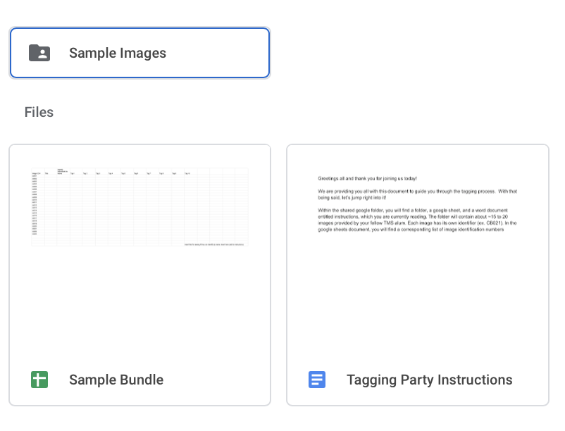

Examples of titles

| 1. Photograph of two children playing in the schoolyard 2. Event Program 3. “The Modern School at 50” |
| --- |

Please be aware that the title you provide might not be the final title used when these images are published, as our team will work to format the titles to be consistent across the collection.

Please use the spreadsheet to insert applicable tags. For each image, you are able to add up to 10 tags. For tags 1 to 10, there is a dropdown menu for you to choose from preexisting tags. Please try to select tags from this list. However, if you would like to suggest a tag that is not listed in the drop down menu, feel free to type in a tag, which can be a word or short phrase. For unlisted tags, please insert using the following format:

| CB021 | Other: (Insert word or phrase) |
| --- | --- |